Final Report

- Project title:
Development of Machine Learning Models for Predicting Properties of Fiber Reinforced Polypropylenes

2. PI (Name and address):
Dr. Tarak K Patra
Department of Chemical Engineering
IIT Madras, Chennai -600036

4. Broad Area of Research: Chemical Engineer
4.1 Sub Area: Polymer Engineering, AI & ML

5. Milestones of the Proposal:
- System Familiarization, Data Collection and Data Processing
- Data Pre-processing and Feature Engineering
- Model development and training
- Model evaluation and interpretation
- Model validation and refinement
- Documentation and Research Finding
6. The start date: September 17, 2024

7. Methodology

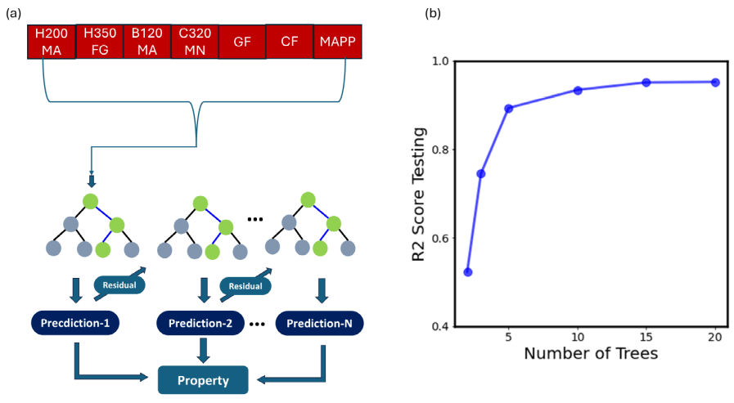
Initially we had developed an XG-Boost model to predict the mechanical properties of fibber reinforce polypropylene. The XGBoost is a gradient boosted tree algorithm that provides a functional approximation of a correlation by optimizing specific loss functions as well as applying several regularization techniques. These techniques penalize the model for being too complex, encouraging it to learn simpler and more generalizable patterns from the data. We have built the XGBoost model in stages. It starts with a decision tree, and trains it on the data. This process continues sequentially, with each new tree learning from the error of the previous ones, as shown schematically in Fig. 1(a). A total of 15 trees are connected in a sequence to build the model, beyond which the model’s performance does not improve further. The depth of each tree is chosen to be 5, wherein the performance is found to be optimal.
Figure 1: XG-Boost Model development. The model architecture is shown in (a). The coefficient of determination R² is plotted as a function of controlling variable – number of trees in the model.

We have also developed Deep Neural Network (DNN) and Gaussian Process Regressor (GPR) models to predict the mechanical properties of fiber reinforced polypropylene. Both models represent fundamentally different mathematical frameworks for regression and machine learning.

Gaussian Process Regressor (GPR) is a Bayesian method that models the underlying function as a distribution over functions. It provides not only predictions but also uncertainty estimates through the covariance structure. GPR is particularly effective for smaller datasets as it can capture complex relationships while naturally regularizing through the kernel function. However, it has computational complexity that scales with the number of training samples.

Deep Neural Networks (DNN), on the other hand, use a hierarchical architecture of interconnected neurons with non-linear activation functions. The DNN framework excels at learning complex, non-linear patterns in data through backpropagation and stochastic gradient descent optimization. The mathematical foundation of DNNs based on universal approximation theorems enables them to capture intricate underlying patterns in data that may not be easily captured by simpler models. Furthermore, DNNs demonstrate superior computational efficiency for inference and can scale well with model complexity. The ability of DNNs to learn multiple levels of abstractions through their layered structure makes them particularly powerful for capturing the multi-scale interactions between composition parameters and resulting mechanical properties.

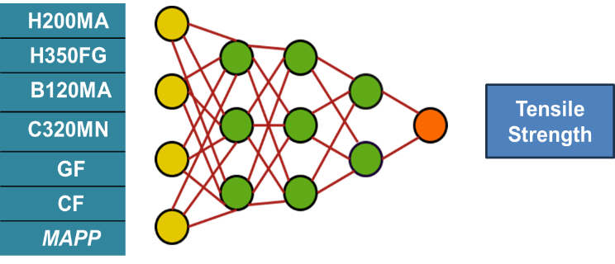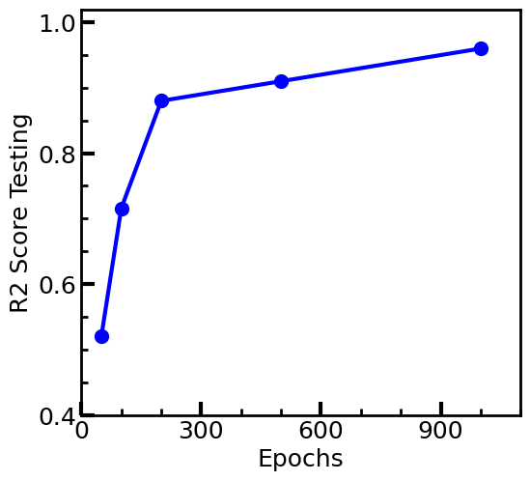

Figure 2: DNN Model development. The model architecture is shown in (a). The coefficient of determination R² is plotted as a function of controlling variable – Epochs

We developed a DNN model with a carefully optimized architecture consisting of 3 hidden layers with 28-14-7-1 neurons respectively. Each layer employs ReLU (Rectified Linear Unit) activation function to introduce non-linearity and enable the model to learn complex mappings. The model was trained using the Adam optimizer with a learning rate of 0.001 and Mean Squared Error (MSE) as the loss function. Through systematic optimization, we determined that 1000 epochs provides the optimal balance between model convergence and generalization, where the R² score reaches its peak performance of 0.96.

8. Salient Research Achievement
8.1 Summary of progress Report:
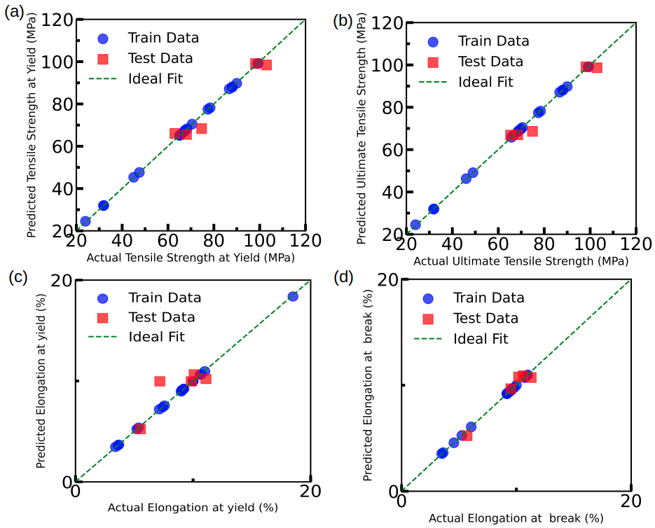
Figure 3: The performance of the XGB models. Here, (a), (b), (c), and (d) correspond to tensile strength, ultimate tensile strength, elongation at yield, and actural elongation at break.

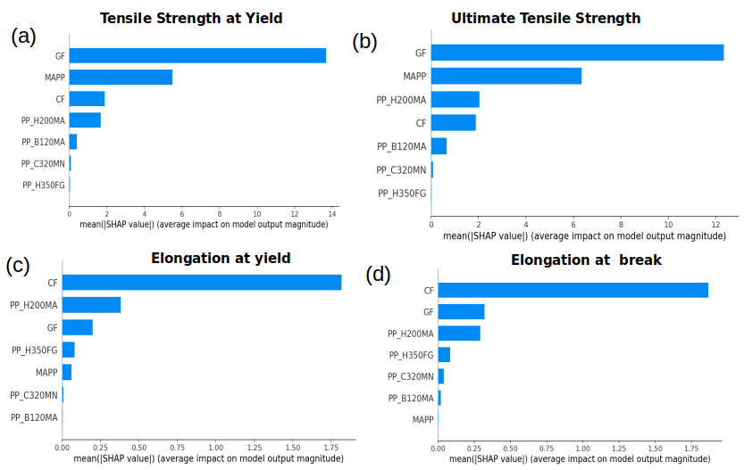
We have 25 samples in our dataset. We split the dataset in training and test set. We keep 20 data points for training and 5 data points for testing. First, we show for how changing Number of trees in XGboost improve model performance in terms of R² score value for Tensile Strength at Yield (Fig. 1b). We stick to 15 Trees for all cases. We show parity plot to show model performance for 4 predictions. The performance of the model is shown in Figure 3. In this parity plot, the x-axis is the actual value, and the y-axis is the predicted value. A y=x is plotted for guiding to the eyes. Points on or
Figure 4: SHAP analyis of the ML model. Here, (a), (b), (c), and (d) correspond to tensile strength, ultimate tensile strength, elongation at yield, and actural elongation at break.
close to y=x is a good prediction. Deviation from the line is denoted as poor prediction. The coefficient of determination (R²) for all the predictions are above 0.9. We further
performed the SHAP analysis of the model as shown in Figure 4. It shows the relative importance of different composition parameters in determining the properties of the material.
Same cases has been shown for the DNN model in figure 5 and 6.

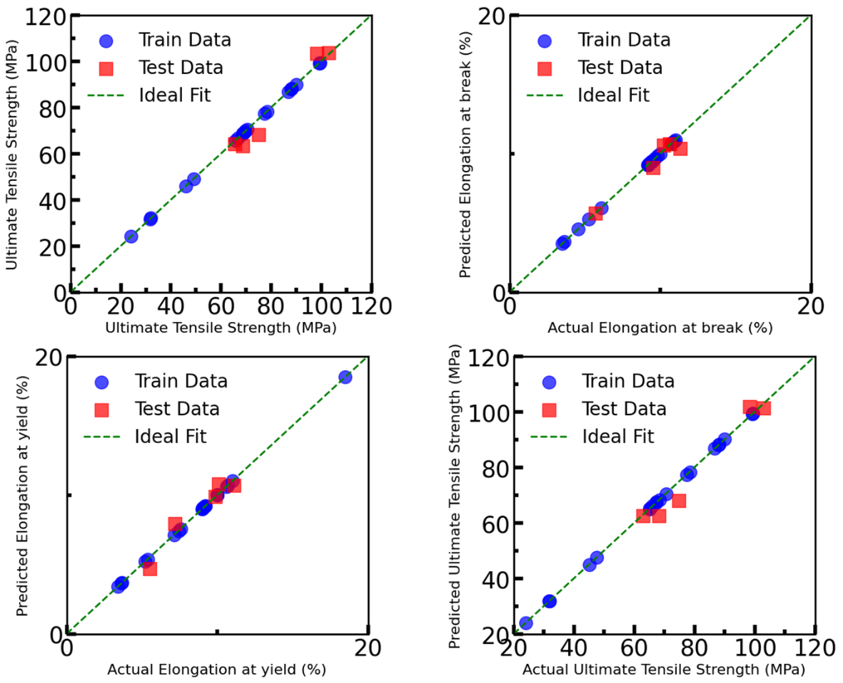
Figure 5: The performance of the DNN models. Here, (a), (b), (c), and (d) correspond to tensile strength, ultimate tensile strength, elongation at yield, and actural elongation at break.
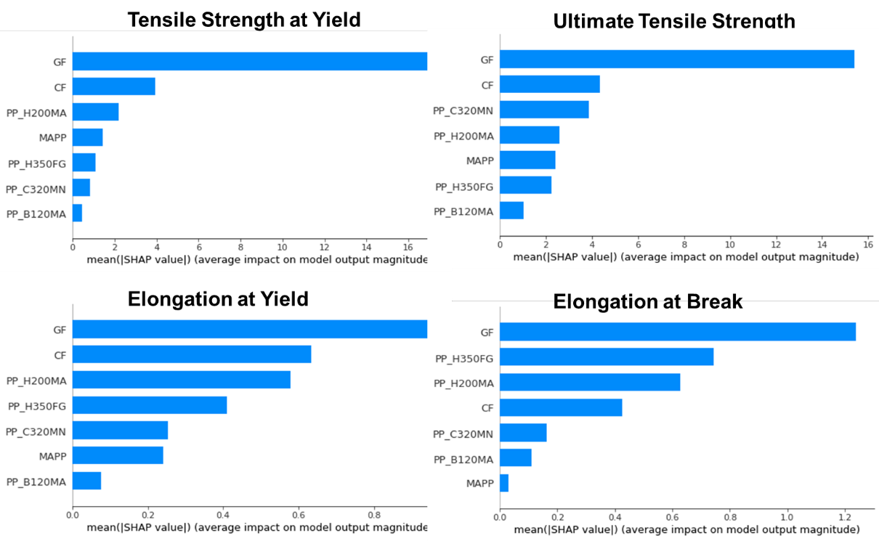
Figure 6: SHAP analysis of DNN model. Here, (a), (b), (c), and (d) correspond to tensile strength, ultimate tensile strength, elongation at yield, and actural elongation at break.

8.2 New Observations:

I. We successfully built ML models with small datasets (25 samples) for predicting multiple mechanical properties of fiber-reinforced composites.

II. We expanded the model from 7 input features to 11 input features by incorporating molecular weight information of different polymers and geometric properties of glass fiber reinforcement.

III. We demonstrated that Deep Neural Networks are slightly superior to traditional gradient boosting methods and GPR for this application. The comparison Test R2 score for different mechanical are shown in figure 7. The DNN's mathematical framework, based on neuron structures and complex non-linear transformations through multiple layers, enables more effective capture of the underlying patterns in the composition-property relationships.

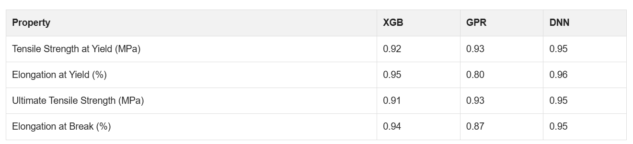

IV. We confirmed that glass fiber concentration remains the highest-order feature in determining mechanical properties across all predictions. The Carbon Fibre plays a secondary but still significant role, particularly for tensile properties.

V. The expanded feature set maintains model performance at R² > 0.90 for all properties, indicating robust generalization. The newly added molecular weight and aspect ratio features are designed as forward-looking features that will become more important as the dataset is expanded with different polymer formulations and glass fiber specifications.
8.3 Innovation:
The model predicts the mechanical properties of fibber reinforced polymers based of the composition of the material. It does not require chemical details of the constituents. The model is computationally very efficient. It does not require large computing time. It can run in a standard desktop computer. DNN seems slightly better in predictions as compared to other algorithms like XG-Boost and GPR.
The inclusion of molecular weight and aspect ratio features creates a framework that can systematically incorporate material property variations, enabling the model to predict for broader ranges of polymer types and reinforcement geometries.
8. 4 Application Potential
This model can be used to screen the composition space of fiber-polymer composites. It can be used to predict the mechanical properties of any target composition of the material. The expanded feature set provides a foundation for extending the model to different polymer systems, fiber types, and reinforcement geometries as new data
becomes available.
9. Summary

Developed and optimized an XGBoost model with 15 sequential trees achieving R² > 0.9 across all four mechanical properties.

Developed Gaussian Process Regressor (GPR) and Deep Neural Network (DNN) models to evaluate different mathematical frameworks.

DNN shows higher predictive accuracy (R² = 0.95).

Designed and optimized 4-layer neural network with 28-14-7-1 neurons, ReLU activation, Adam optimizer (lr=0.001), and identified optimal training at 1000 epochs.

We have Systematically expanded input features from 7 to 11 by incorporating molecular weight of polymer grades and glass fiber aspect ratio.

Retrained DNN on expanded 11-feature dataset maintaining R² > 0.90 for all properties, demonstrating robust generalization.

We have Performed comprehensive SHAP analysis identifying glass fiber as the dominant feature with new features positioned for future material variations.

